Grid

Grid is often praised for easy placement of items in a two-dimensional layout. If you’ve been struggling to get your flex items to all match evenly in size, grid can make this type of layout much easier.

In CSS, an element is turned into a grid container with the property: display:grid or display:inline-grid.

The properties grid-template-columns and grid-template-rows make defining column and row tracks easy.

For example:

HTML:
<div class=’container’>
<div>Item 1</div>
<div>Item 2</div>
<div>Item 3</div>
<div>Item 4</div>
</div>

CSS:
.container{
display:grid;
grid-template-columns:50px 50px;
grid-template-rows:50px 50px;
}
.container > div{
border:2px solid black;
padding:2px;
}
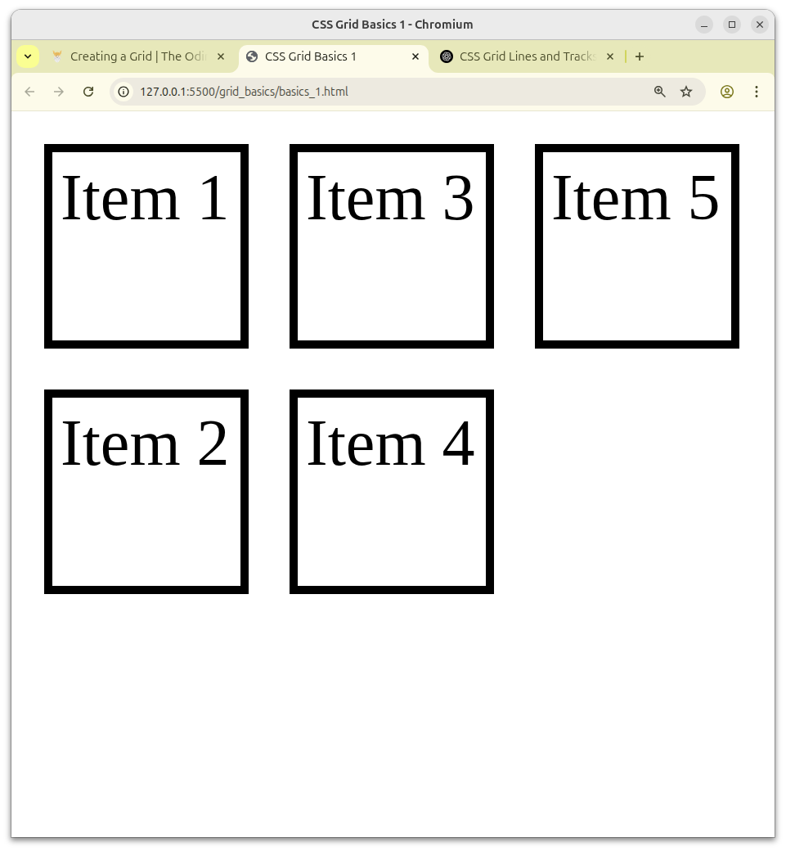

CSS grid shorthand property for grid-template-rows & grid-template-columns is grid-template.

Example: grid-template: 50px 50px / 50px 50px 50px.

Implicit grid concept is used when grid needs more tracks for extra content. We can set the implicit grid track sizes using the grid-auto-rows and grid-auto-columns.

Example: grid-auto-columns: 50px;

It would be much less common to want extra content added horizontally along the grid, but that can be set using grid-auto-flow: column property.

Gap sizes can be adjusted separately for rows and columns using the column-gap and row-gap properties or use shorthand property called gap.

